**RRJETAT E KOMPJUTERAVE 1**

**LAB 2**

**Tema:** Konfigurimi bazik i nje Toplogjie Rrjeti me ane te Packet Tarcer;

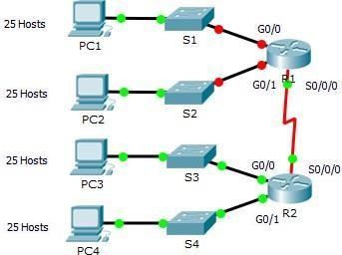

**Skenari - Subnetting**

Në këtë aktivitet, ju jepet adresa e rrjetit 193.162.98.0/24 për ndarjen ne nënrrjete dhe adresimin IP për topologjinë e treguar më sipër. Çdo LAN në rrjet kërkon hapësirë të mjaftueshme për, të paktën, 25 adresa për pajisjet fundore, switch-in dhe ruterin. Lidhja midis R1 dhe R2 do të kërkojë një adresë IP për çdo ndërfaqe lidhur.

**Step 1:** Subnet the 193.162.98.0/24 network into the appropriate number of subnets.

1. Based on the topology, how many subnets are needed?
2. How many bits must be borrowed to support the number of subnets in the topology table?
3. How many subnets does this create?
4. How many usable hosts does this create per subnet?

Note: If your answer is less than the 25 hosts required, then you borrowed too many bits.

1. Calculate the binary value for the first five subnets.

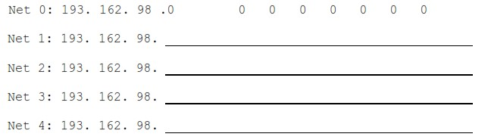

1. Calculate the binary and decimal value of the new subnet mask.

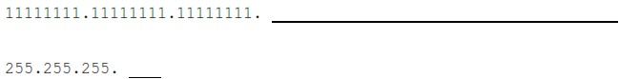

1. Fill in the Subnet Table, listing the decimal value of all available subnets, the first and last usable host address, and the broadcast address. Repeat until all addresses are listed.

Note: You may not need to use all rows.

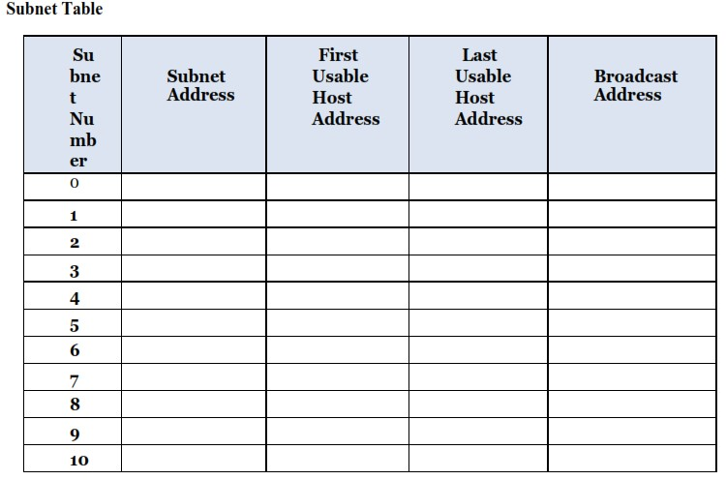

**Step 02:** Assign the subnets to the network shown in the topology.

1. Assign Subnet 0 to the LAN connected to the GigabitEthernet 0/0 interface of R1.
2. Assign Subnet 1 to the LAN connected to the GigabitEthernet 0/1 interface of R1.
3. Assign Subnet 2 to the LAN connected to the GigabitEthernet 0/0 interface of R2
4. Assign Subnet 3 to the LAN connected to the GigabitEthernet 0/1 interface of R2
5. Assign Subnet 4 to the WAN link between R1 to R2

**Step 3:** Document the addressing scheme.

Fill in the Addressing Table using the following guidelines:

1. Assign the first usable IP addresses to R1 for the two LAN links and the WAN link.
2. Assign the first usable IP addresses to R2 for the LANs links. Assign the last usable IP address for the WAN link.
3. Assign the second usable IP addresses to the hosts.
4. Assign the last usable IP addresses to the hosts.

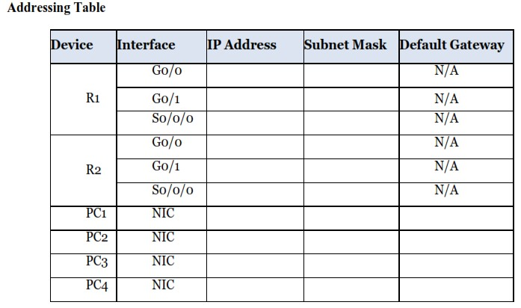

**Assign IP Addresses to Network Devices and Verify Connectivity**

Most of the IP addressing is already configured on this network. Implement the following steps to complete the addressing configuration.

**Step 1: Configure IP addressing on R1 LAN interfaces.**

**Step 2: Configure IP addressing on S3, including the default gateway**  **Step 3: Configure IP addressing on PC4, including the default gateway.**

**Step 4: Verify connectivity.**

You can only verify connectivity from R1, S3, and PC4. However, you should be able to ping every IP address listed in the Addressing Table.

**Skenari - Subnetting**

Në këtë aktivitet, ju jepet adresa e rrjetit 193.162.98.0/24 për ndarjen ne nënrrjete dhe adresimin IP për topologjinë e treguar më sipër. Çdo LAN në rrjet kërkon hapësirë të mjaftueshme për, të paktën, 25 adresa për pajisjet fundore, switch-in dhe ruterin. Lidhja midis R1 dhe R2 do të kërkojë një adresë IP për çdo ndërfaqe lidhur.

**Step 1:** Subnet the 193.162.98.0/24 network into the appropriate number of subnets.

Required host: 25

25= 32 host -> numri total i adresave te hosteve

25 – 2= 30 host -> numri i hosteve te perdorshem

23= 8 subnets -> numri total i subneteve

193.162.98.00000000/24

000 -> bitet per subnet

00000 -> bitet per hoste te perdorshem

1. Based on the topology, how many subnets are needed? **5**
2. How many bits must be borrowed to support the number of subnets in the topology table? **3 bits**
3. How many subnets does this create? **23= 8 subnets**
4. How many usable hosts does this create per subnet? **25-2 = 30 hosts**

Note: If your answer is less than the 25 hosts required, then you borrowed too many bits.

1. Calculate the binary value for the first five subnets.

Net 0: 193. 162. 98. 0 0 0 0 0 0 0 0

Net 1: 193. 162. 98. 0 0 1 0 0 0 0 0

Net 2: 193. 162. 98. 0 1 0 0 0 0 0 0

Net 3: 193. 162. 98. 0 1 1 0 0 0 0 0

Net 4: 193. 162. 98. 1 0 0 0 0 0 0 0

1. Calculate the binary and decimal value of the new subnet mask.

11111111. 11111111. 11111111. 111. 00000

255. 255. 255.224

1. Fill in the Subnet Table, listing the decimal value of all available subnets, the first and last usable host address, and the broadcast address. Repeat until all addresses are listed.

Note: You may not need to use all rows.

**Subnet Table**

|  |  |  |  |  |
| --- | --- | --- | --- | --- |
| **Subnet** | **Subnet**  **Address** | **First Usable**  **Host Address** | **Last Usable**  **Host Address** | **Broadcast**  **Address** |
| **0** | 193.162.98.0 | 193.162.98.1 | 193.162.98.30 | 193.162.98.31 |
| **1** | 193.162.98.32 | 193.162.98.33 | 193.162.98.62 | 193.162.98.63 |
| **2** | 193.162.98.64 | 193.162.98.65 | 193.162.98.94 | 193.162.98.95 |
| **3** | 193.162.98.96 | 193.162.98.97 | 193.162.98.126 | 193.162.98.127 |
| **4** | 193.162.98.128 | 193.162.98.129 | 193.162.98.158 | 193.162.98.159 |

**Step 02:** Assign the subnets to the network shown in the topology.

* 1. Assign Subnet 0 to the LAN connected to the GigabitEthernet 0/0 interface of R1. **193.162.98.0**
  2. Assign Subnet 1 to the LAN connected to the GigabitEthernet 0/1 interface of R1. **193.162.98.32**
  3. Assign Subnet 2 to the LAN connected to the GigabitEthernet 0/0 interface of R2. **193.162.98.64**
  4. Assign Subnet 3 to the LAN connected to the GigabitEthernet 0/1 interface of R2. **193.162.98.96**
  5. Assign Subnet 4 to the WAN link between R1 to R2. **193.162.98.128**

**Step 3:** Document the addressing scheme.

Fill in the Addressing Table using the following guidelines:

1. Assign the first usable IP addresses to R1 for the two LAN links and the WAN link.
2. Assign the first usable IP addresses to R2 for the LANs links. Assign the last usable IP address for the WAN link.
3. Assign the second usable IP addresses to the hosts.
4. Assign the last usable IP addresses to the hosts.

**Addressing Table**

|  |  |  |  |  |
| --- | --- | --- | --- | --- |
| **Device** | **Interface** | **IP Address** | **Subnet Mask** | **Default Gateway** |
|  | Go/o | 193.162.98.1 | 255.255.255.224 | N/A |
| R1 | Go/1 | 193.162.98.33 | 255.255.255.224 | N/A |
|  | So/o/o | 193.162.98.129 | 255.255.255.224 | N/A |
|  | Go/o | 193.162.98.65 | 255.255.255.224 | N/A |
| R2 | Go/1 | 193.162.98.97 | 255.255.255.224 | N/A |
|  | So/o/o | 193.162.98.158 | 255.255.255.224 | N/A |
| PC1 | NIC | 193.162.98.30 | 255.255.255.224 | 193.162.98.1 |
| PC2 | NIC | 193.162.98.62 | 255.255.255.224 | 193.162.98.33 |
| PC3 | NIC | 193.162.98.94 | 255.255.255.224 | 193.162.98.65 |
| PC4 | NIC | 193.162.98.126 | 255.255.255.224 | 193.162.98.97 |

# **Assign IP Addresses to Network Devices and Verify Connectivity**

Most of the IP addressing is already configured on this network. Implement the following steps to complete the addressing configuration.

**Step 1: Configure IP addressing on R1 LAN interfaces.**

**Step 2: Configure IP addressing on S3, including the default gateway**

**Step 3: Configure IP addressing on PC4, including the default gateway.**

**Step 4: Verify connectivity.**

You can only verify connectivity from R1, S3, and PC4. However, you should be able to ping every IP address listed in the Addressing Table.

